



PMI Project, Program & Portfolio Conference

Wednesday August 18th, 2010

Using Project Server 2010 for Project, Program & Portfolio Management

Presented by: Tim Runcie, MCP, MCTS, PMP, MVP
www.Advisicon.com


Advisicon, Inc.
1515 SE 122nd • Portland, Oregon 97233 • (503) 253-0331
www.Advisicon.com

Overview of Technology & Methodology:

Understanding of MS 2010 Architecture and Goals:

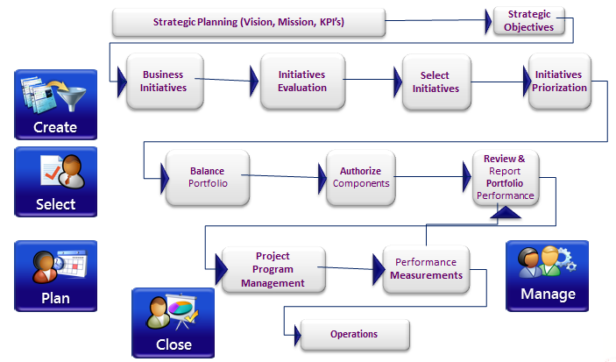

NOTES

How Does MS 2010 Technology Blend with Methodology:
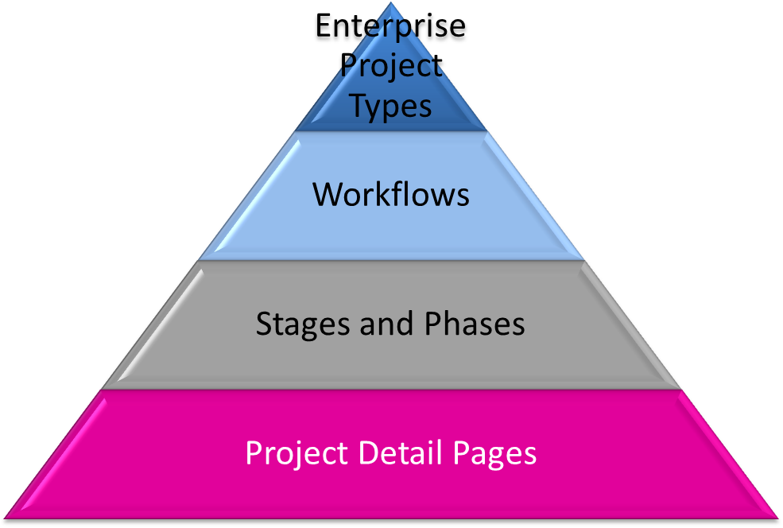
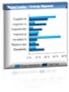
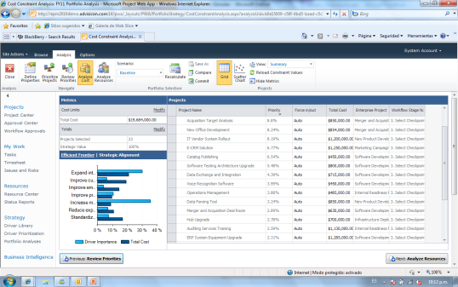





Portfolio Mgmt.
Organizational Resources
Project / Program Mgmt.

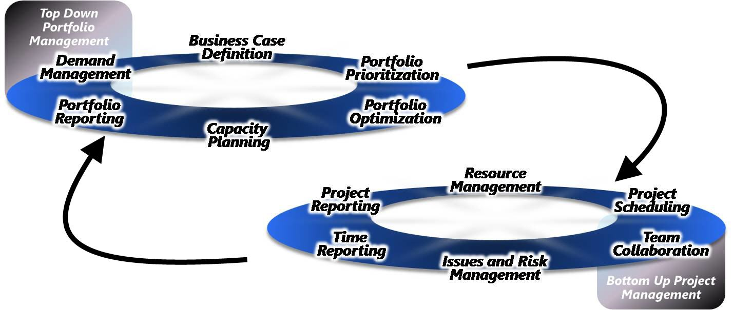

NOTES

Project Server 2010 PM Capabilities:
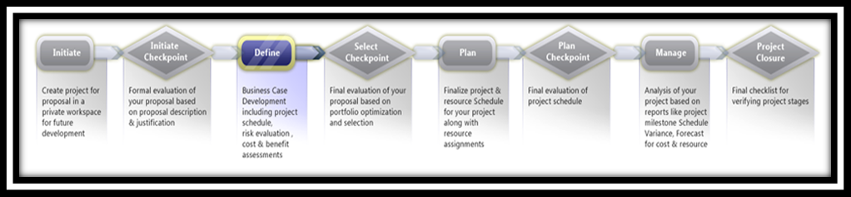

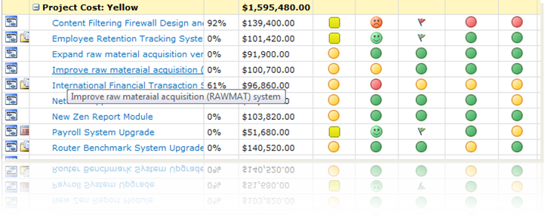
The Staging of Project Data:

- Project Client
- Project Client to SharePoint
- Project Server Published

NOTES

Workflows & Stage gates:

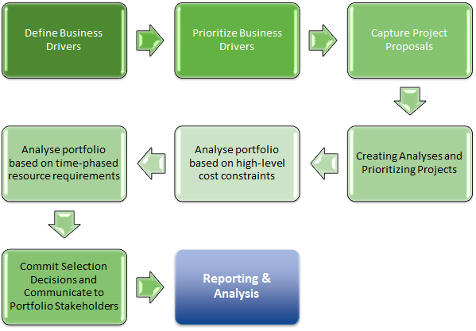

NOTES

Portfolio Management with Project Server:

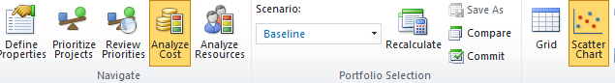

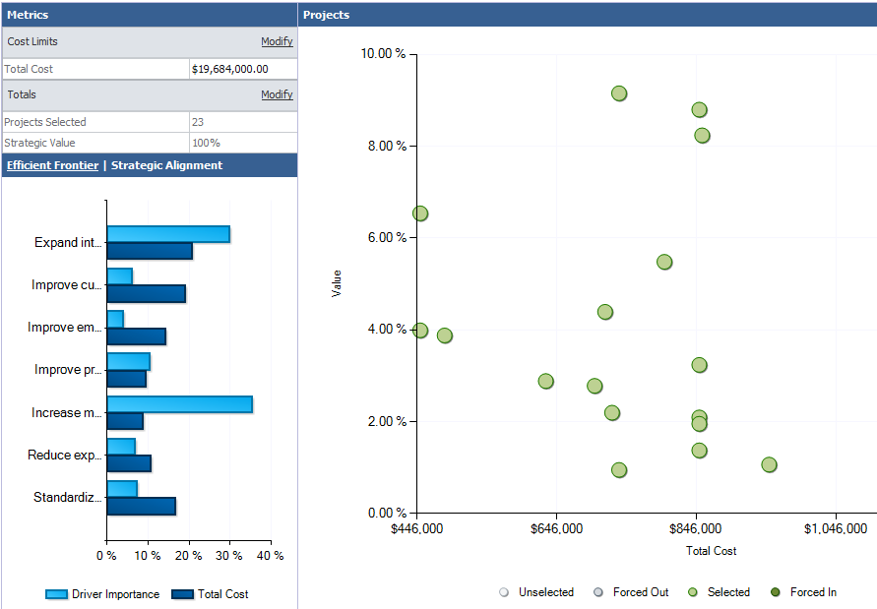
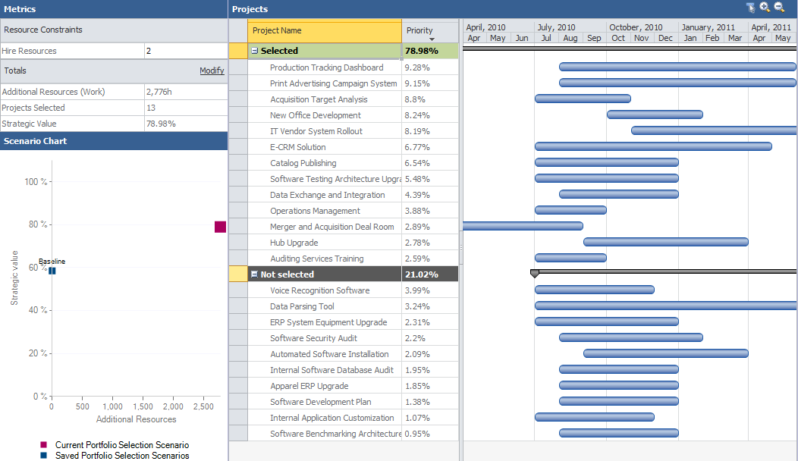

NOTES

Project & Portfolio Reporting:

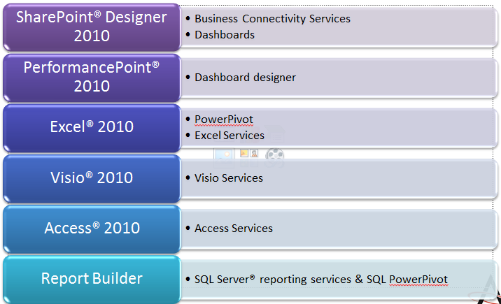

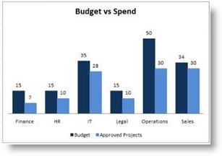

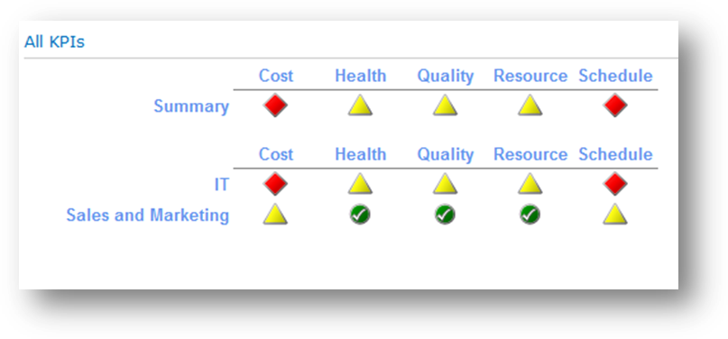

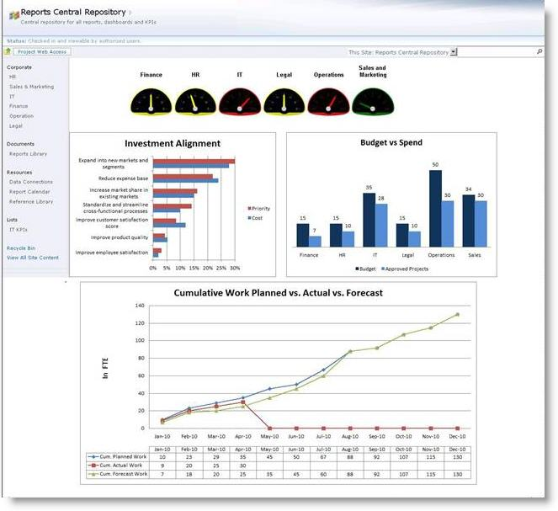

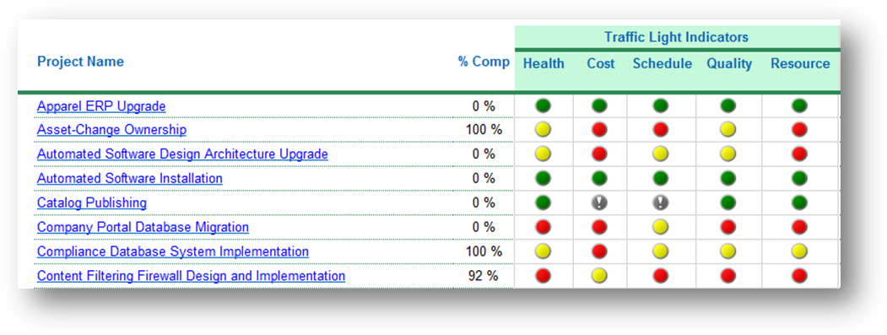

NOTES

References:

- Product information and trial download
  - Main product site www.microsoft.com/project/2010/
  - Project Team Blog http://blogs.msdn.com/project/
- End-User Product Help
  - Project 2010 Help http://office2010.microsoft.com/project-help
  - Project 2010 Help: Info@Advisicon.com
  - Project Server 2010 Help http://office2010.microsoft.com/project-server-help
- Interactive content – Videos/Sessions/Webcasts
  - www.microsoft.com/showcase/en/US/channels/microsoftproject/
  - www.microsoft.com/events/series/epm.aspx
- Project & Project Server 2010 Demo Image
  - Download http://go.microsoft.com/?linkid=9713956
  - Hosted Virtual Lab http://go.microsoft.com/?linkid=9713654
- IT Professional related - TechNet
  - TechCenter http://technet.microsoft.com/ProjectServer/
  - Admin Blog http://blogs.technet.com/projectadministration/
- Developer related - MSDN®
  - Developer center http://msdn.microsoft.com/Project/
  - Programmability blog http://blogs.msdn.com/project_programmability/
- Got questions? Project Forums!
  - http://social.msdn.microsoft.com/Forums/en-US/category/projectserver2010,projectprofessional2010/
  - www.info@Advisicon.com
  - Tim.Runcie@Advisicon.com
  - Kevin.Williamson@Advisicon.com
  - Tim.Cermak@Advisicon.com
- Blogs:
  - http://blogs.msdn.com/b/chrisfie/ (Christophe)
  - http://blogs.technet.com/b/doug_mccutcheon/ (Doug)
  - www.AdvisiconBlog.com
- Microsoft® SharePoint® 2010
  - http://sharepoint.microsoft.com

Call Advisicon for Your PM Consulting and Training Solution
- Assessments and optimization consulting for project and work management
- Microsoft® Project, Project Server, and SharePoint solution and integration consulting (all versions)
- Custom Application Development (complex databases, integrations, reports, workflows and dash-views)
- Dynamic project scheduling, program administration and staffing services and consulting
- Project Management training:

- PMP Preparation
- Practical Project Management
- Mastering Requirements Gathering
- Managing Projects with Microsoft Project
- SharePoint for Effective Project Management

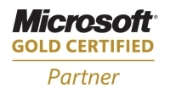
Advisicon is the only Microsoft Gold Certified Enterprise Project Management Partner in the Pacific Northwest and is uniquely qualified to help organizations with:
- Microsoft Office Project and Project Server 2007 or 2010
- SharePoint & Customized Dashboards or Workflows

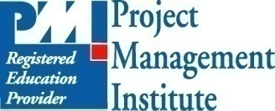
Advisicon is a Global Registered Education Provider (REP) of the Project Management Institute (PMI). Our clients have confidence knowing that they have chosen an organization that is qualified to provide the highest level of project management training, and the convenience of receiving Professional Development Units (PDUs).

